Grover Cox and Cox’s Sporting Goods
by
Ron Gast

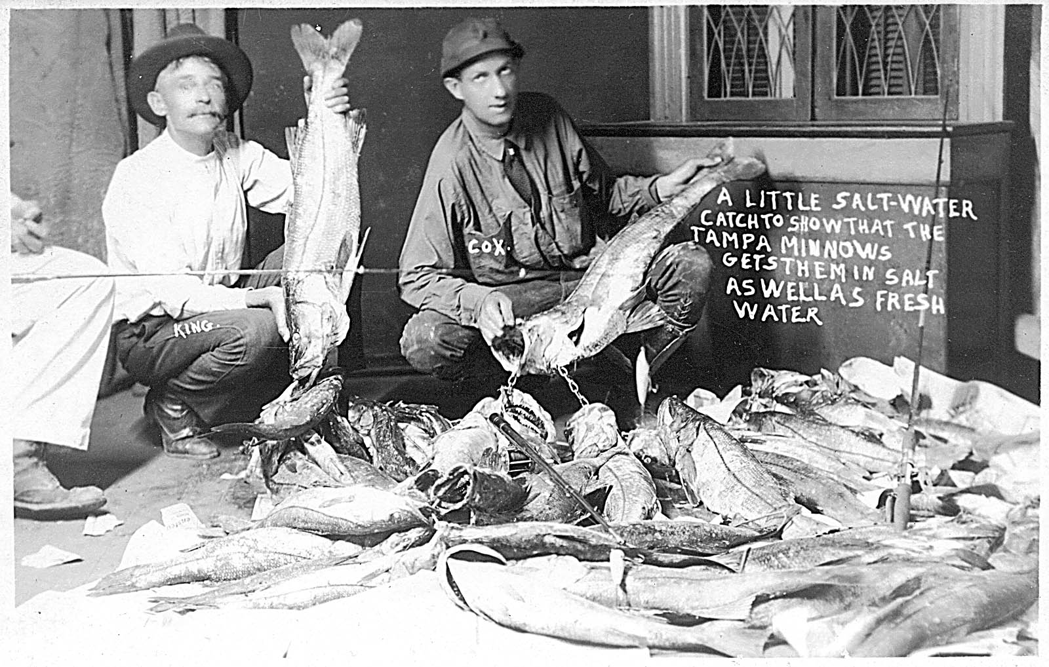

The group stood over the pile of fresh caught fish. All were starting to feel tired after a night of fishing in Tampa Bay. The clean clothes they had just put on did not do a lot to help relieve their fatigue.

“Well, the snook really like that minnow Grover,” Mr. King said to Mr. Cox. “I have never seen them go after one like that before,” he said.

“Yeah, I’m really pleased with it. It has the action they can’t resist,” Grover said turning to Mr. King. “I see the photographer is here so let’s go ahead and get behind these fish so he can take some pictures. This will make some great publicity for my new minnows. Oh, one of you boys go ahead and dangle one of my minnows in front of us over the fish. That’ll be a nice touch”

Such are the visions one conjures up in seeing the old photograph postcard of Grover Cox and his fish. We’ll never know how the scene actually came about, but it’s fun to imagine.

One thing we do know is that Grover Cox has the privilege and honor of being the first Floridian to make a commercially available wooden fishing lure. This fact has made his lures some of the most desirable ones for collectors. The Tampa Minnows are well constructed and have hardware suitable for catching large fish. His lures were made in a time when the fishing tackle businesses were taking off. Heddon, Shakespeare, Pflueger, Creek Chub and Wilson were all coming out with high quality baits on the market.

Grover C. Cox was born in Jonesboro, NC in 1884. It is not known when he moved to Florida, but the first listing for him in the Tampa, FL City Directory was in 1912. His profession is listed as only bicycles. The following year was the first mention of sporting goods as his occupation.

The sporting goods line of business in Tampa must have been good for him. In February 1915, he placed his first advertisement for Grover Cox in the Tampa Tribune newspaper. He was listed as the distributor in south Florida for the Smith Motor Wheel motorized bicycle. Other ads would later follow showing baseball and tennis equipment, keys cut to order and a variety of bicycles. Tampa Minnows were also advertised in the paper.
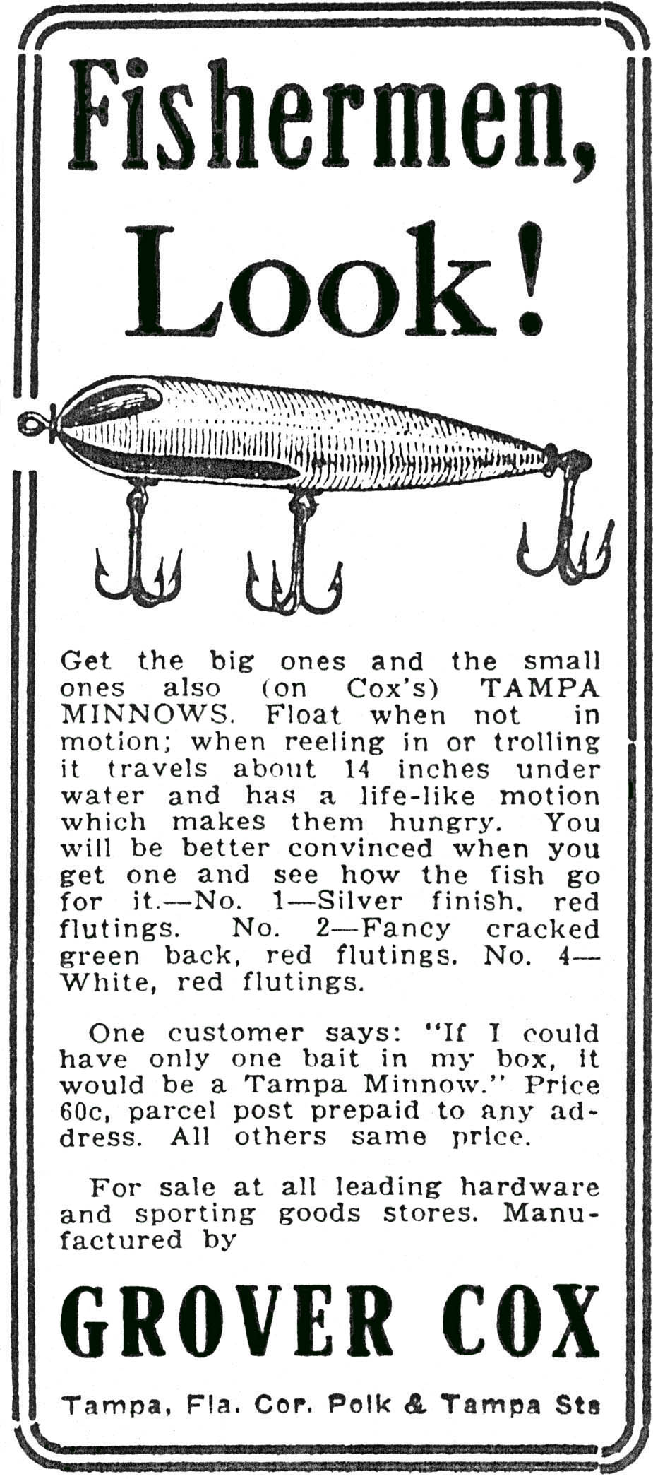
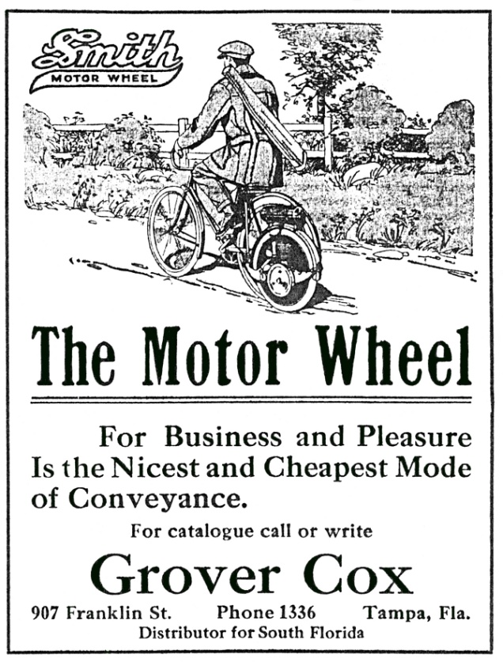

1915 Tampa Tribune Newspaper Ad

In 1920, the company name would be changed from Grover Cox to Cox’s Sporting Goods. It remained so into the 1930’s.

So far, there have been three lures identified as Cox Tampa Minnows. They are a Wilson Wobbler type lure, a tapered nose Wobbler type lure with a metal diving blade, and a no-chin Zaragossa type lure. His newspaper ads did not provide a specific name for each one, however.

The earliest Tampa Minnow is first seen in a July 1916 ad in the Tampa Tribune. The lure

1916 Tampa Tribune Newspaper Ad
resembles a Wilson Fluted Wobbler with the exception the top two grooves in the wood extend aft only a fraction of the amount of the lower ones. Wilson’s lure had already been on the market since about 1910. Since Cox dealt in fishing tackle in his sporting goods store, he was undoubtedly aware of the Wilson bait. It’s possible that this first design of Cox’s was his improved version of the Wobbler. This Cox bait came in three colors.
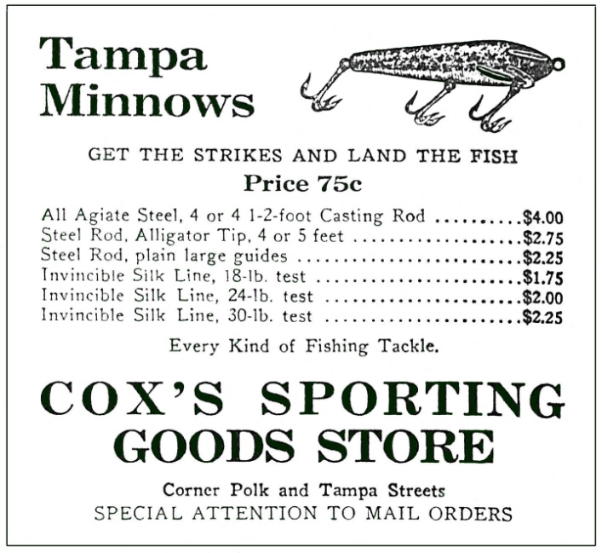
Cox’s next lure is the most recognizable one and the one most often identified as the Tampa Minnow. This Tampa Minnow first appeared in Tampa Tribune ads in 1918. It too has design features similar to a Wilson Wobbler. The one exception is the distinctive metal diving blade. Two versions have been found. One has holes for eyes and the other has no eyes. Both exude character and the appearance of an early, classic bait. With the introduction of this bait, the first Wobbler-type lure was no longer offered in advertisements.

1920 Tampa Tribune Newspaper Ad

The third Tampa Minnow is one that is almost a mirror image of the Heddon no-chin Zaragossa. It has the same body style, has glass eyes and has a concave chin. The two distinct features of the Tampa Minnow that are different from the Zaragossa, however, are the belly hook hardware and the paint pattern. Tampa Minnows have characteristic hook hardware cups that have very wide flanges. Also, the quality of the paint job does not compare to Heddon’s. The Zara-type Tampa Minnow frog pattern is colorful, unique and attractive, but is susceptible to cracking. This lure is the one shown dangling over the pile of snook in the Cox photograph.

The questions that come to mind with the Zara-type Tampa Minnow are which came first and were there any relations between Cox and Heddon. The patent for the Heddon no-chin Zara was granted to William Stolley of Heddon’s Sons in 1922. Since Stolley and James Heddon were good friends and he ran the Heddon factory, he probably came down to Florida with the Heddons. Stolley was an outdoorsman and inventor and would have been drawn to Cox’s store if for no other reason than to see what the competition was doing. The Stolley patent follows one year after Cox stopped offering Tampa Minnows. Did Heddon buy the rights to the no-chin? Was the no-chin really invented by Stolley and was Cox forced to stop making it? Time will hopefully tell.

Cox eventually assigned names to two of his Tampa Minnows in 1920. Unfortunately, the pictures of the lures are not shown along with the ads for the Minnows. The “BASDEX” Tampa Minnow came in a frog spotted pattern and is probably the no-chin Zara-type lure. The Florida Fisherman magazine ad states that Cox manufactures the “BASDEX” in nine distinct types. This must refer to slight variations in body style and color patterns. The other named Tampa Minnow was the “FISH HAWK.” It came in frog color and red and white. However, there is no indication of what style of lure the “FISH HAWK” was.
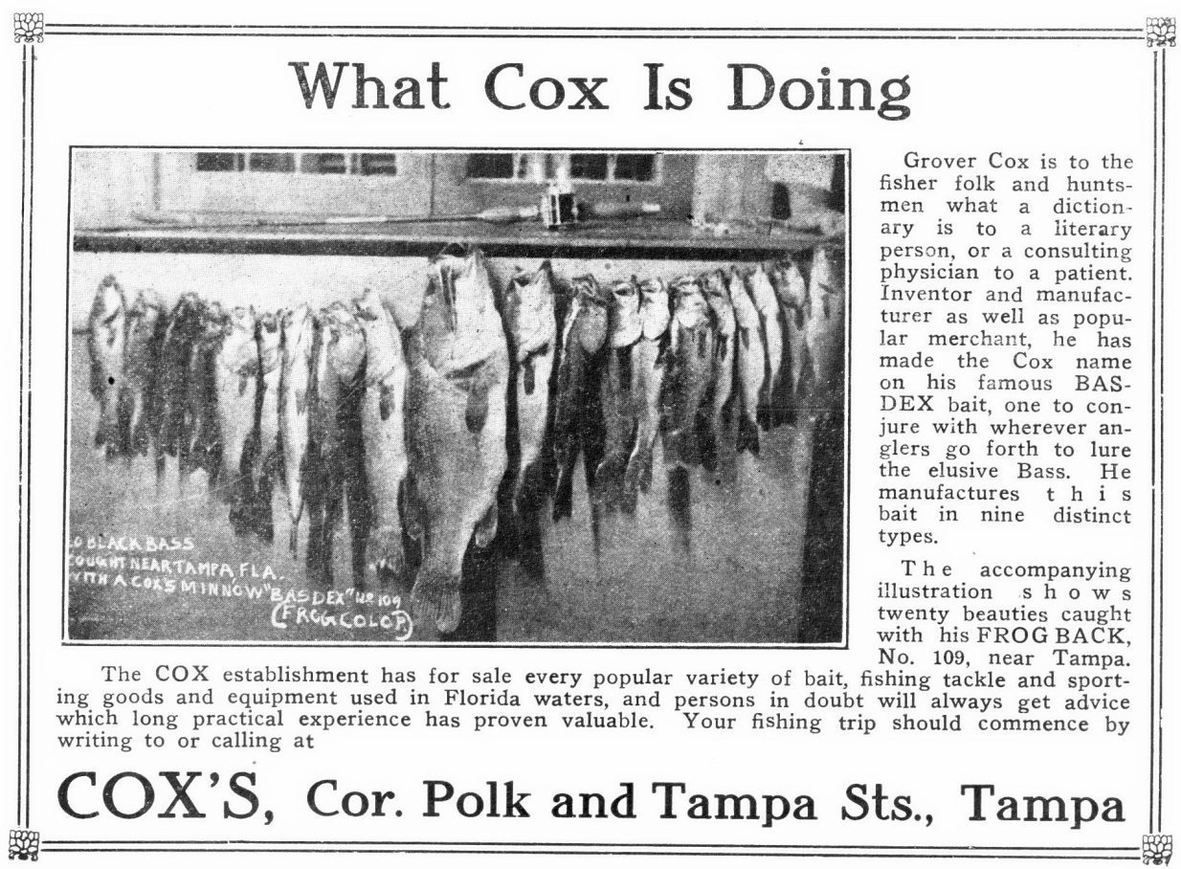

Ad From the September, 1920 Magazine Edition of “The Florida Fisherman”

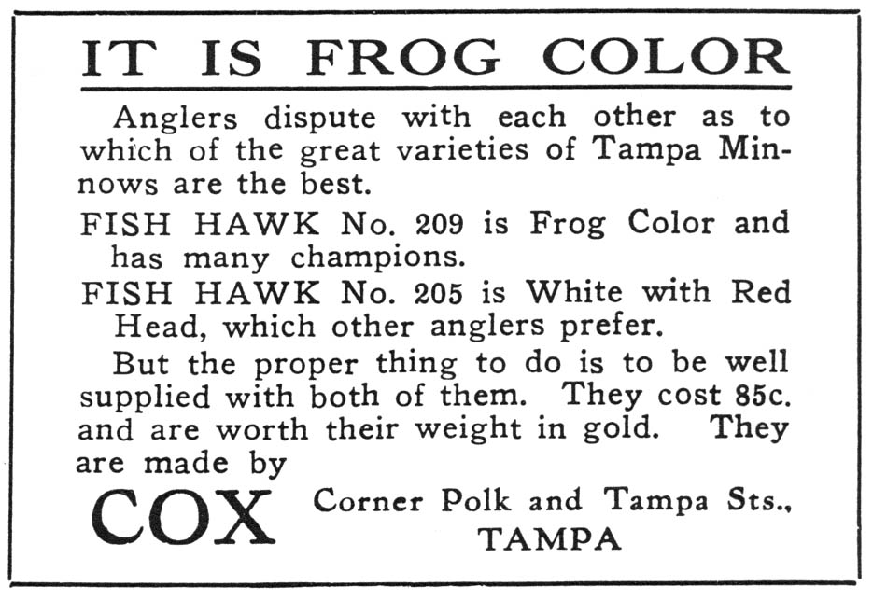
The Tampa City Directory shows that the Cox’s store location moved four times during it’s 25 years in business. From 1912 to 1915, it was located at 907 Franklin. From 1916 to 1921, the store was at 201 Polk St and was at 713 Florida Ave. from 1922 to 1926. The final location was at 1106 Tampa Street. It is interesting to note that the Tampa Minnow advertisements show only the Polk Street address.
Ad From the March, 1921 Magazine Edition of “The Florida Fisherman”

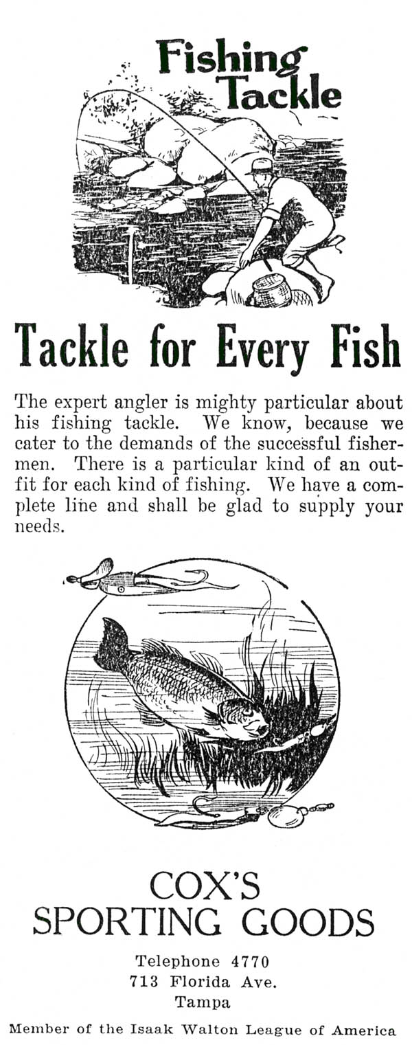
A 1922 fishing tackle ad for the store when it was located at 713 Florida Ave. no longer promoted the Tampa Minnow. The ad shows Al Foss baits in the advertisement cut. He apparently was no longer making the Tampa Minnow. The Tampa Minnows were therefore probably sold for only about 6 years from 1916 to 1921.

Grover Cox left Cox’s Sporting Goods store in 1932 to start a new endeavor. The Tampa City Directory in 1933 lists his occupation as Airport Golf Club owner. Cox’s Sporting Goods lists Fred Shaffer as president and Grover’s wife Emma as secretary-treasurer. Grover’s occupation in subsequent years was listed as the Airport Golf Club until his death. He died at the age of 54 on December 4, 1938.

The obituary for Grover Cox lists his survivors as his wife Emma, his sisters Mrs. Charlie Jones and Miss Ruth Cox of Tampa and Mrs. Oscar Lemon of Pine Wood, SC and a brother Marsdon Cox of Latta, SC. The obituary also recognized Cox as a well-known outdoorsman and leader in sporting goods in the Tampa area.

The Cox Tampa Minnow story will continue to evolve as more information is discovered. Let’s hope we continue to learn more.
1922 Advertisement

